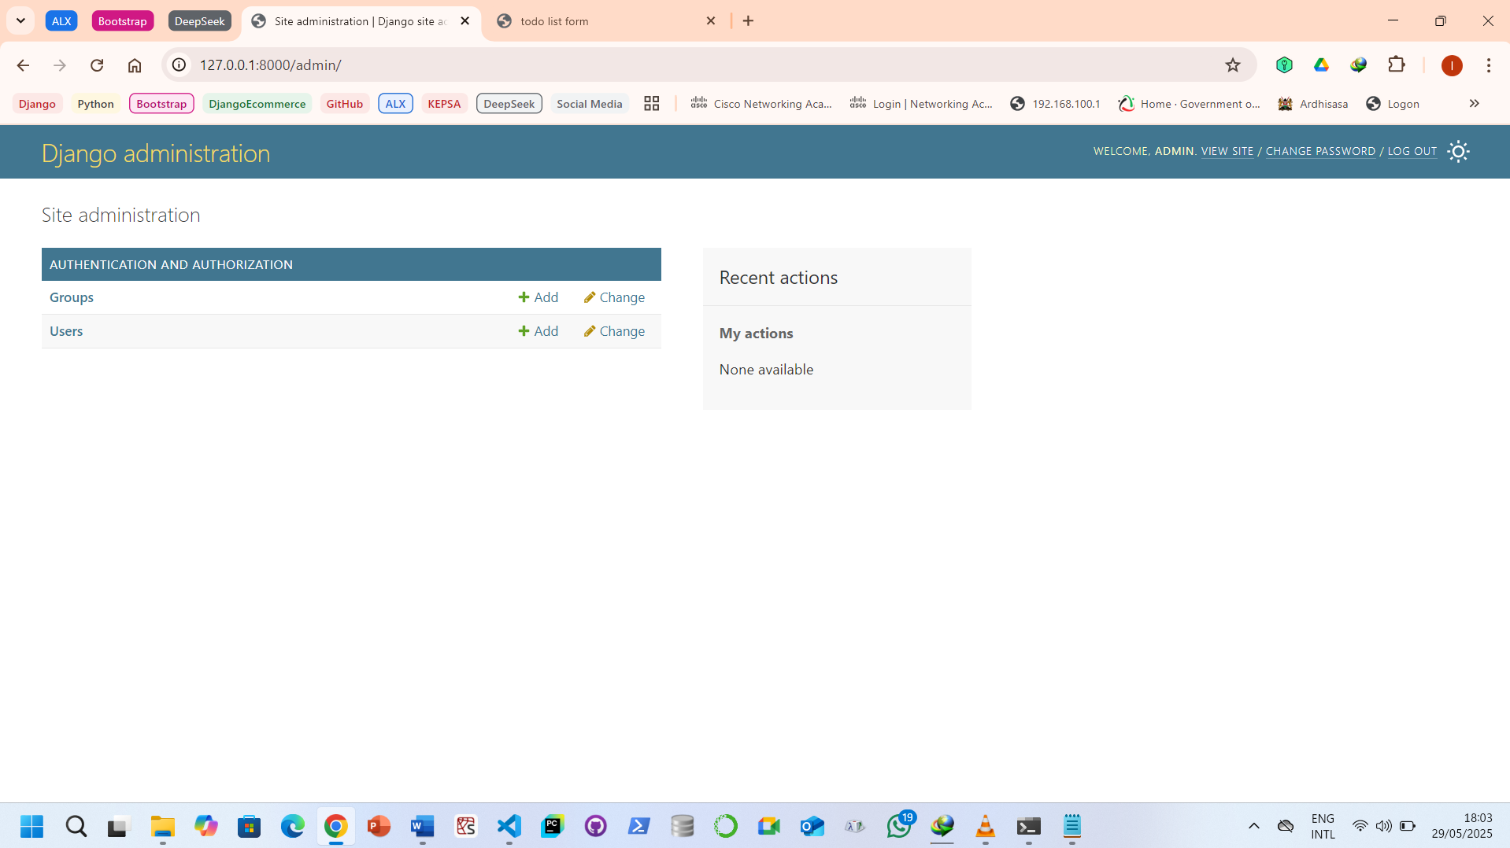

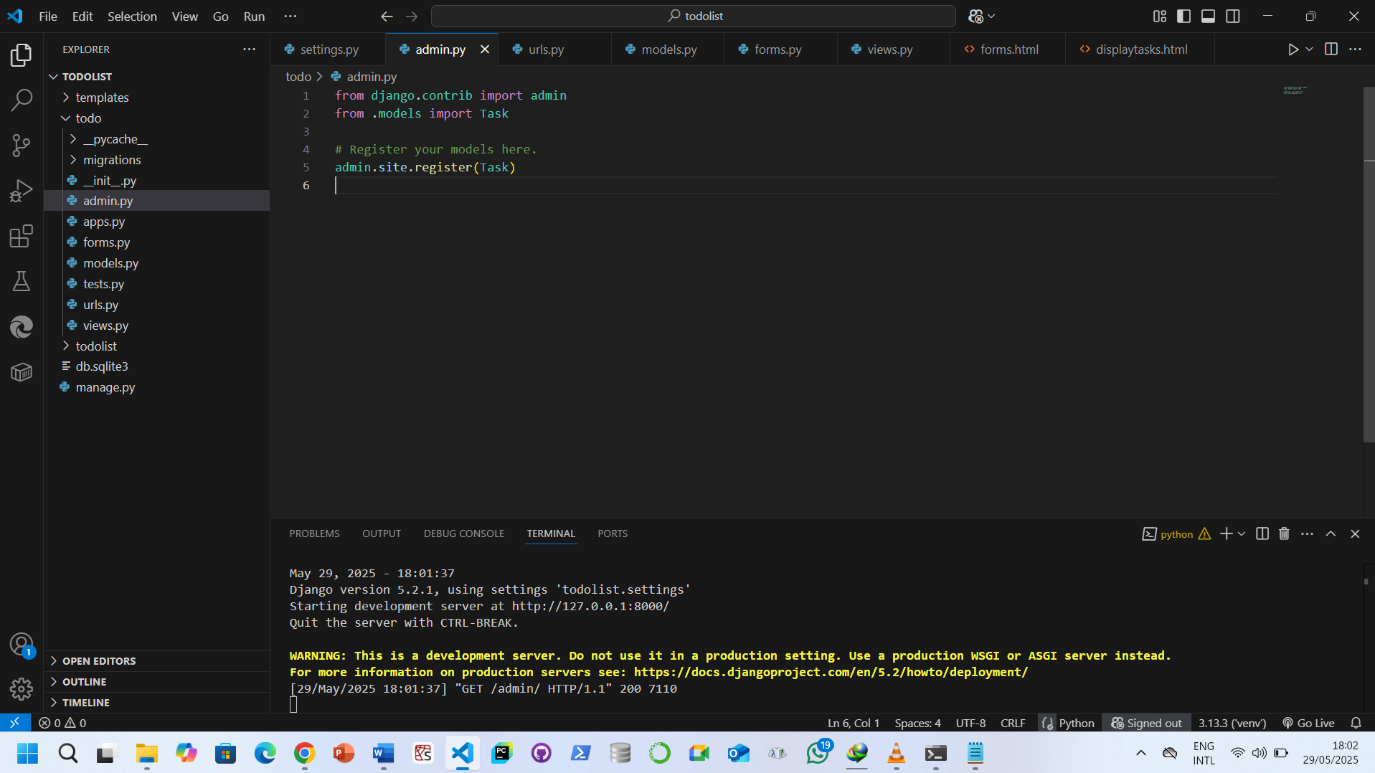

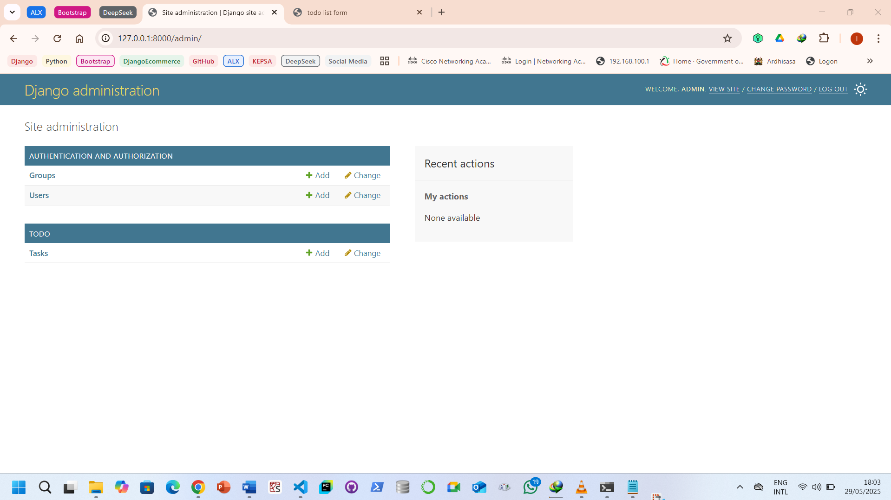

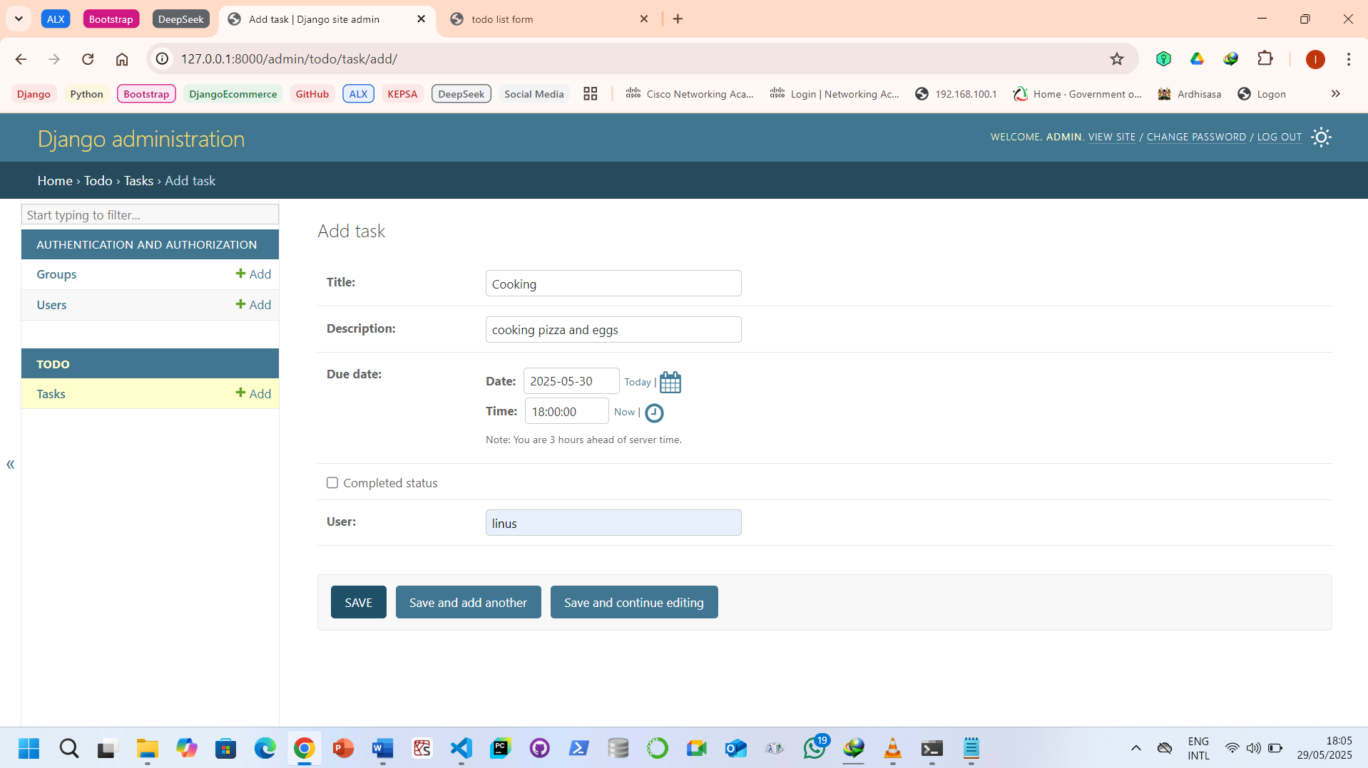

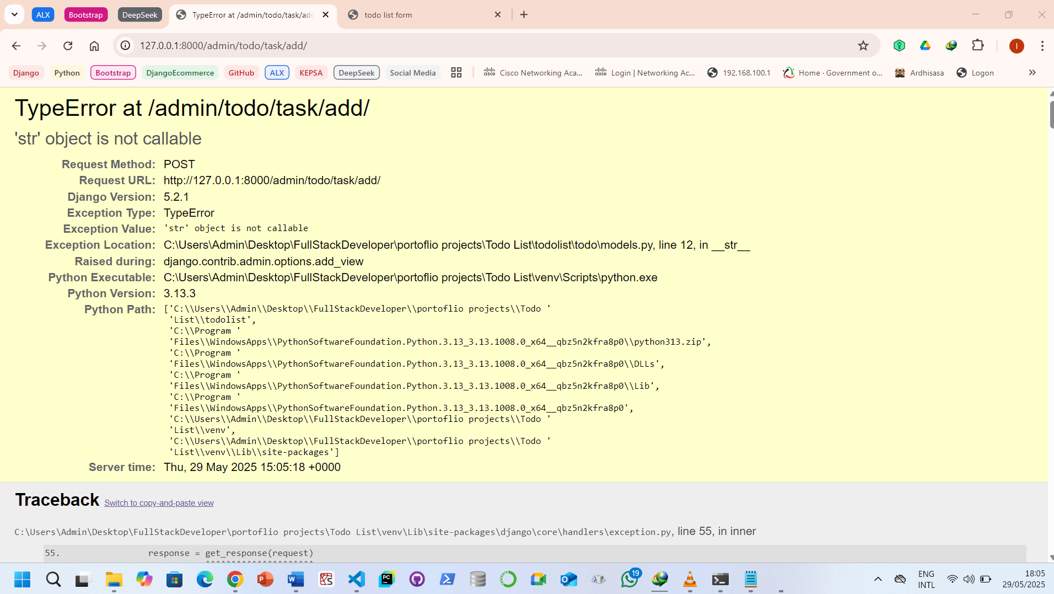

That error — **TypeError: 'str' object is not callable** — usually means you **used parentheses () with a string**, which is invalid in Python.

Since it’s happening at /admin/todo/task/add/, the issue is likely in your models.py file, specifically in the __str__ method of your Task model.

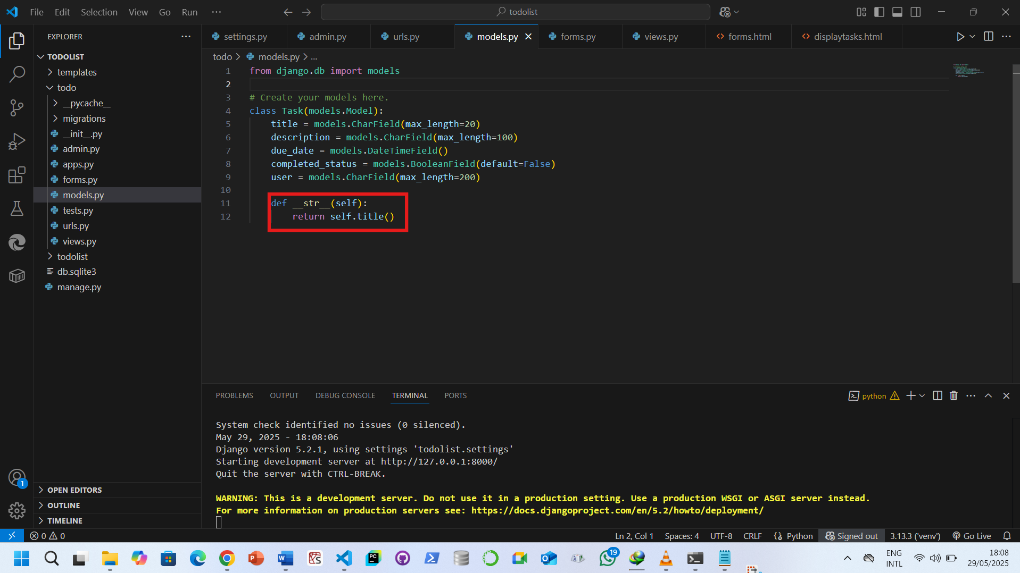

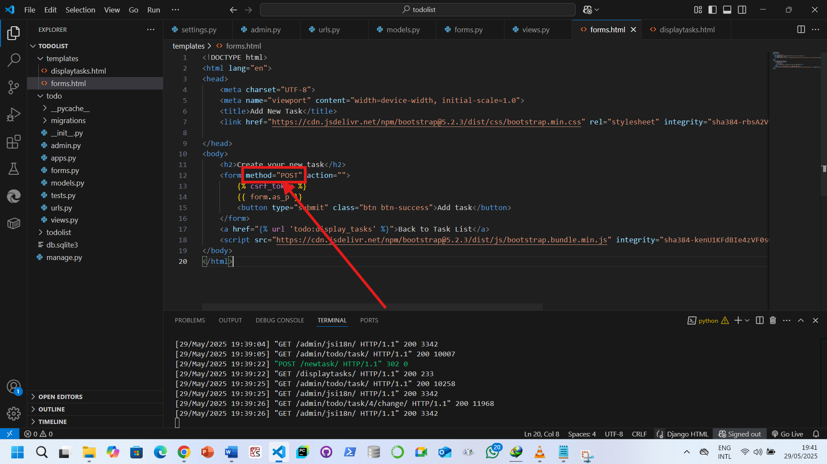

**Explanation:**

* method="POST" tells the browser to send the form data to your view as a POST request.
* button type="submit" is a proper submit button — it triggers the form submission.
* action="" is fine to leave out (or leave as empty) — it will submit to the current URL.

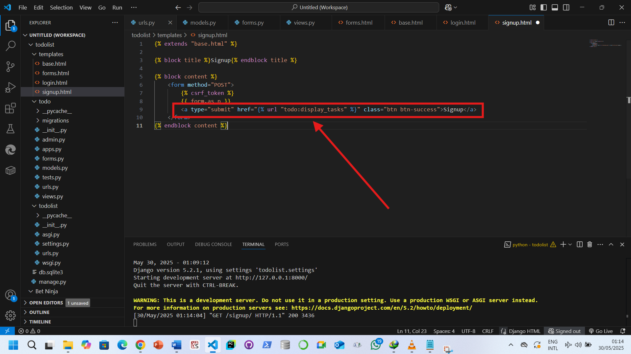

• <a> tags don’t submit forms.

• The form never hits POST, so form.is_valid() is never even run.